Basics of Computer Networks

A computer network is a telecommunication (tele means communication over distance) framework that allows digital devices (nodes) to exchange data via wired or wireless connections to share resources, such as hardware or software (e.g., the Internet). It is a collection of autonomous computers interconnected by a single technology. Networks vary in sizes, shapes, and forms, and they are often connected to create larger networks, with the Internet being the most prominent example-a network of networks.
Wireless devices

An autonomous computer means a computer that can operate independently. In a distributed system, autonomous computers are separate devices that communicate with each other over a network using agreed-upon protocols.
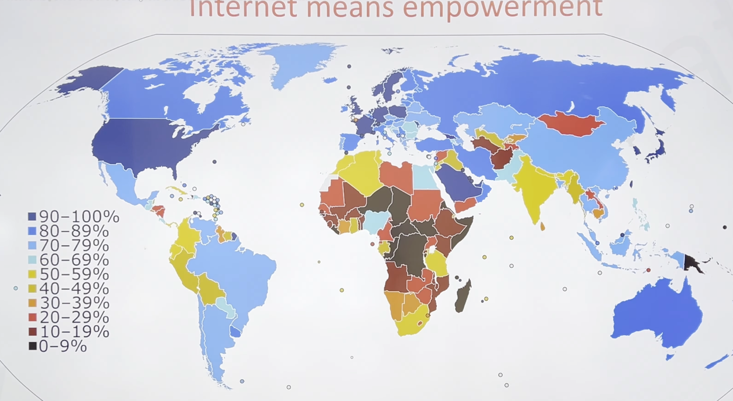

Internet usage shows how widely people in a country use the internet. Higher internet usage can contribute to economic growth by improving access to information, education, jobs, and business opportunities. Basically, this can lead to empowerment, as people gain more opportunities and resources to improve their lives.

Data communication:

Data communication is the exchange of data between two devices via a transmission medium. A data communication system has five components
- Message- information (data) to be communicated e.g. text, audio, video.
- Sender- device that sends the message (computer, phone, camera, etc.)
- Receiver- device that receives the message (computer, phone, television.
- Transmission medium - the physical path by which a message travels from sender to receiver.
- Protocol - the set of rules that governs data communication.

- Effectiveness of the data communications system depends on four fundamental characteristics:

- Delivery- Must deliver the data to correct destination.
- ﻿﻿﻿Accuracy- Must be delivered accurately without any error.(what you send should be delivered correctly)
- ﻿﻿﻿Timeliness- Must deliver the data promptly, sometime time in real time applications data delivered after time is useless.(if a message is sent now, it should be received in a short time shouldn’t take longer time for a receiver to receive )
- Jitter- Refers to variation in the packet arrival time i.e. the uneven delay between the packets (mismatch in audio and picture in a video) (if one packet is getting delayed the other should also follow that delay in order to be right)

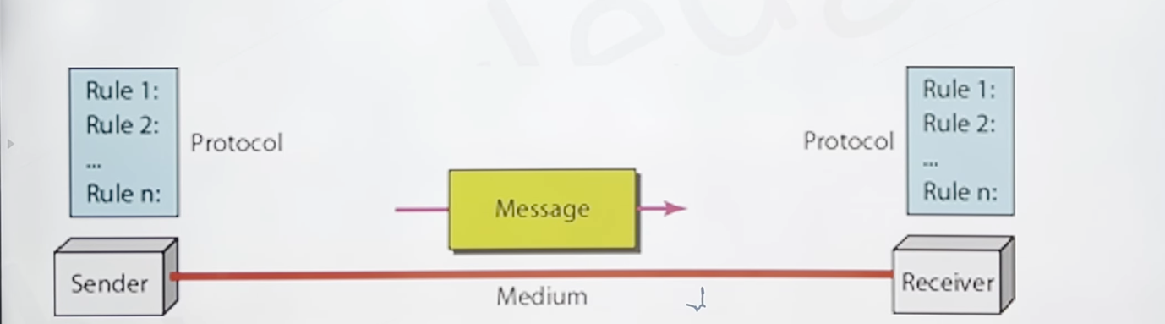

- Transmission mode between two systems can be categorised into three types:

- Simplex - The communication is unidirectional, like a one-way street. One device can always send; the other can always receive. E.g. radio, mouse.

- ﻿﻿The simplex mode can use the entire capacity of the channel to send data in one direction (which means that the sender can send the data to the receiver and the receiver can receive the data but won’t be able to reply to the sender; that’s why it called simplex)

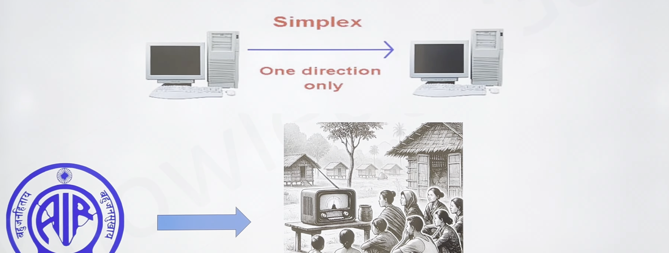

- Half duplex - each station can both transmit and receive, but not at the same time. E.g. like a one-lane road, walkie-talkie, etc.

- When one device is sending, the other can only receive, and vice versa.
- In a half-duplex transmission, the entire capacity of a channel is taken over by whichever of the two devices is transmitting at the time.
﻿﻿Walkie-talkies are half-duplex systems.
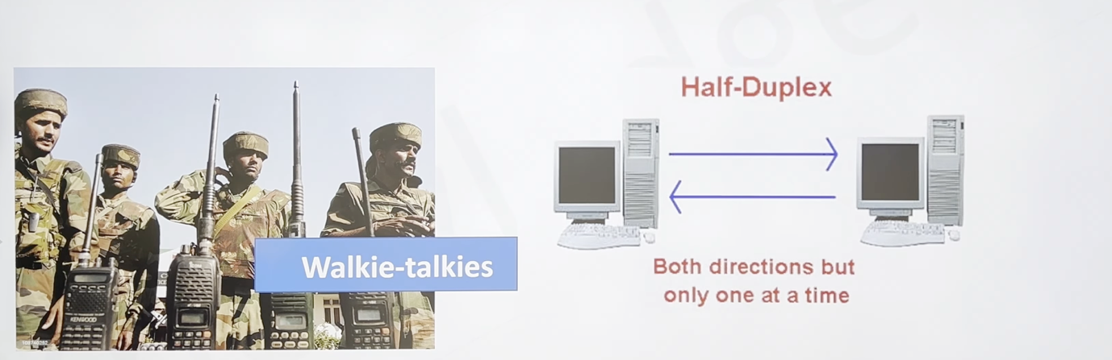

- Full duplex - both stations can transmit and receive at the same time. It is two half-duplex connections.( A simple way to understand it is that in simplex communication, one device sends data and the other receives it, with communication happening in only one direction.
In half-duplex communication, both devices can send and receive data, but not at the same time. One device sends while the other receives, and then they can switch roles.
In full-duplex communication, both devices can send and receive data simultaneously through the same communication channel, allowing two-way communication at the same time.
For example, imagine you are on a phone call with someone. You can both speak and hear each other at the same time. However, if you can hear the other person but they cannot hear you, that indicates a problem with the communication, rather than an example of full-duplex communication.
)

- A telephone network is an example of full-duplex mode: when two people are communicating by a telephone line, both can talk and listen at the same time.
- The channel capacity must be divided between the two directions.

- Network criteria-a network must be able to meet a certain number of criteria. The most important of these are performance, reliability and security.

- Performance - Can be measured in many ways including transit time, response time, number of users, type of transmission medium, capabilities of connected hardware's and efficiency of software.
- Reliability - Is a measure of frequency of failure and the time taken to resolve the failure.
- Security - Includes protecting data from unauthorised access, protecting data from damage and development.

- Types of connection-

- Point-to-point - A point-to-point connection provides a dedicated link between two devices. Most point-to-point connections use an actual length of wire or cable to connect the two ends, but other options, such as microwave or satellite links, are also possible.

- Multipoint - A multipoint (also called multidrop) connection is one in which more than two specific devices share a single link.

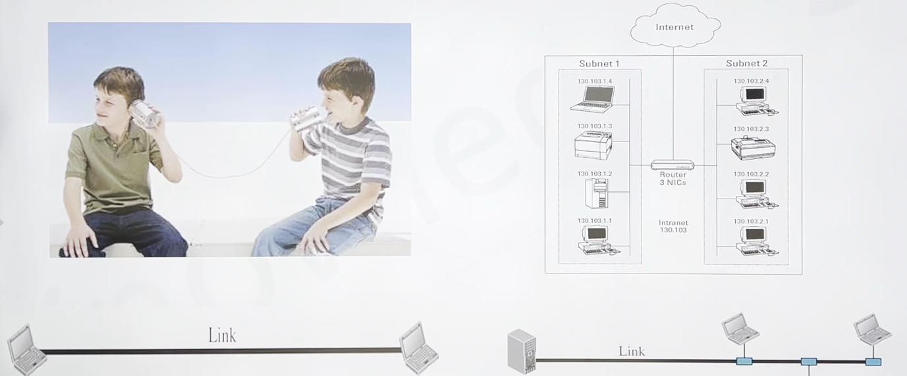

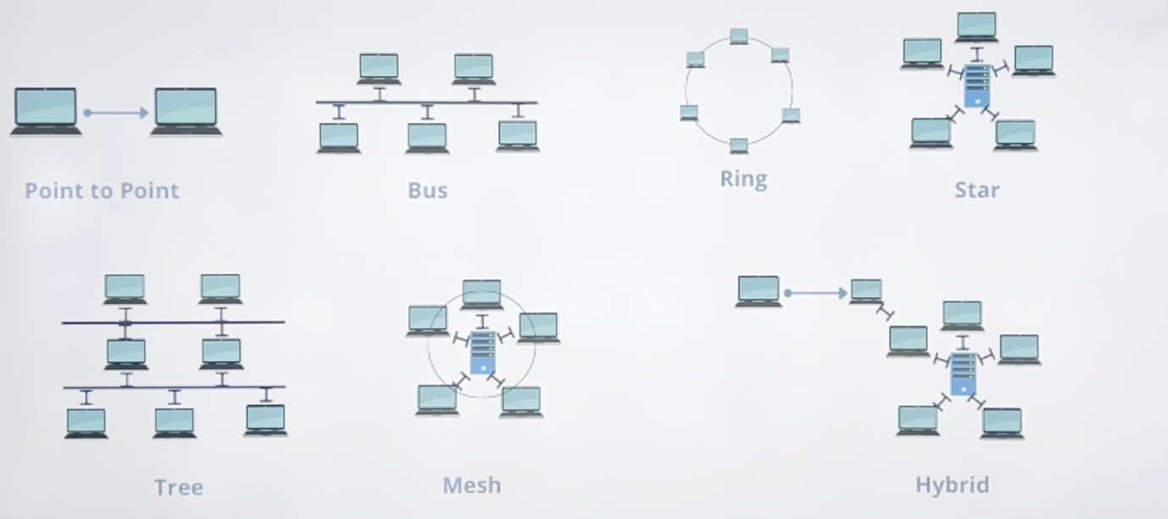

Mesh Topology:

- Mesh Topology
- In a mesh topology, each device has a dedicated point-to-point link to every other device.
- Requires n(n-1)/2 duplex-mode links for n nodes.

- Advantage:
Dedicated links eliminate traffic issues, provide robustness, ensure privacy, and make fault identification easy.
- Disadvantage:
﻿﻿Difficult installation, high wiring bulk, and expensive hardware requirements.
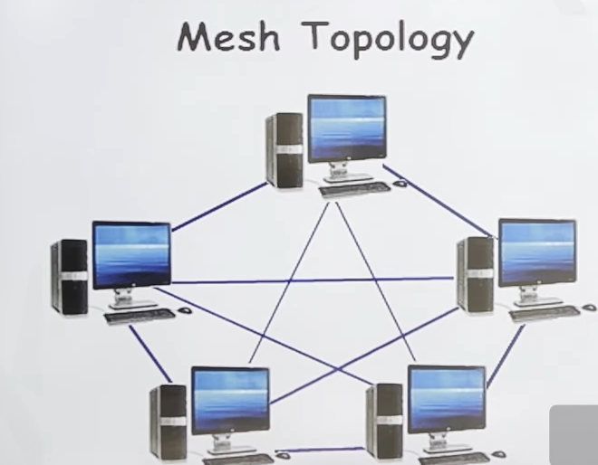

Star Topology:

- Each device has a dedicated point-to-point link to a central hub that manages communication between devices.

Advantage:
Easy to install, reconfigure, and identify faults. It is robust (failure of one link doesn’t affect the rest), and less expensive than a mesh topology.

Disadvantage:
﻿﻿The entire network depends on the central hub, and if it fails, the whole system is affected. Requires more cabling than other topologies.

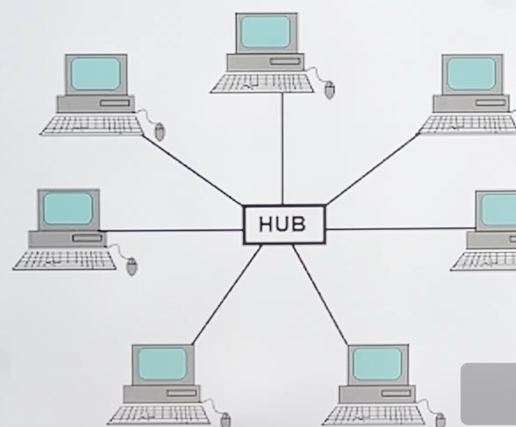

Bus Topology

- A multipoint topology where one long cable acts as a backbone connecting all devices. Devices connect to the backbone via drop lines and taps.
Advantage:
Easy to install and requires less cabling compared to mesh or star topologies.

Disadvantage:
Faults are difficult to isolate, and a break in the bus cable halts all transmissions. It is also &challenging to add new devices.

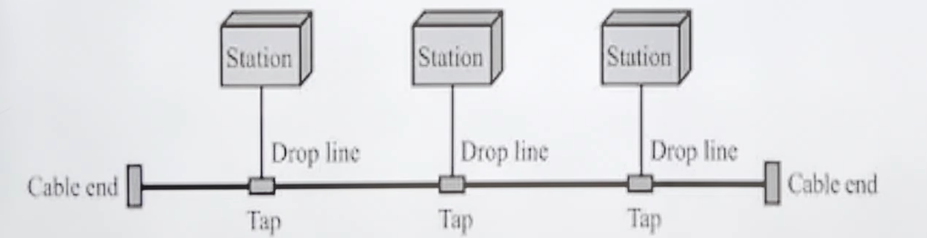

Ring Topology

- In a ring topology, each device connects directly to two adjacent devices, forming a closed loop. Data signals travel in one direction through each device until they reach their destination. Each device functions as a repeater, regenerating the signal before passing it to the next.

Advantages:
Simple installation and reconfiguration. Easier fault isolation.

Disadvantages:
﻿﻿ A single point of failure (like a disabled device) can disrupt the entire network.
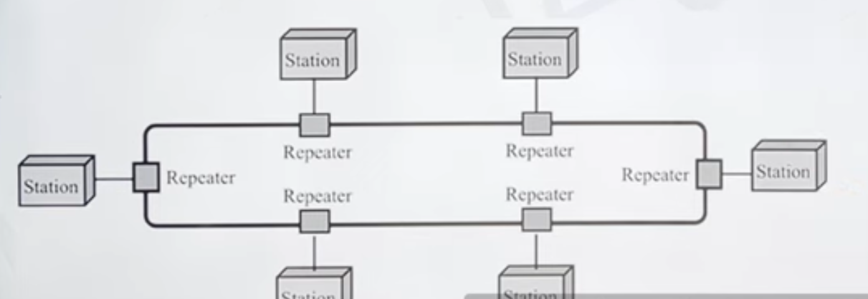

Network Models

- The OSI model, proposed by the International Organisation for Standardisation (ISO), enables communication between different systems irrespective of their underlying architecture. It serves as a conceptual framework for creating flexible, robust, and interoperable network architectures, not as a protocol itself.
- Open System: A set of protocols allowing different systems to communicate.
- Purpose: To facilitate system communication without modifying hardware or software logic.
- Structure: Comprises seven interrelated layers, each defining a specific part of the information transfer process across a network.

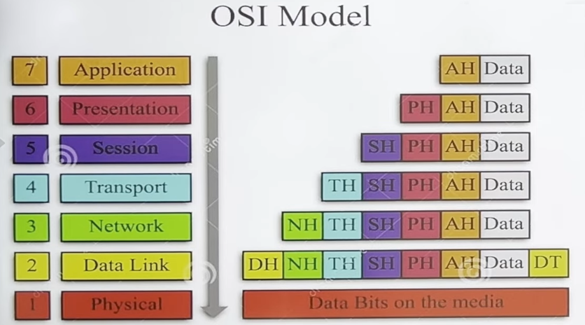

In the OSI model, each layer adds its own header to the data as it moves down the layers on the sender's side. The Data Link layer adds both a header and a trailer.
This process is called encapsulation.
On the receiver's side, the data moves up the layers, and each layer removes and processes its corresponding header (and the Data Link layer also removes its trailer). This process is called decapsulation.
Finally, the receiver gets the original data sent by the sender.

Layered Architecture

Each layer on one machine communicates with the same layer on another machine, following a set of rules called protocols. Within a single machine, each layer relies on the services of the layer below it and provides services to the layer above. The processes that communicate between layers are known as peer-to-peer processes.

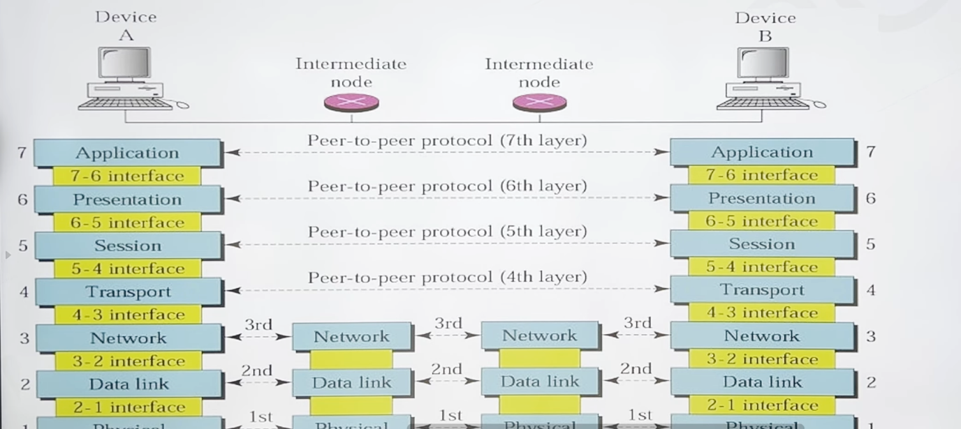

Physical Layer Overview
The physical layer defines the basic interface between devices and the transmission medium.
Key Responsibilities:
- Bit Representation: Manages the raw bit stream (Os and 1s) and converts them into signals (electrical or optical) for transmission.
- Data Rate: Determines the number of bits transmitted per second.
- Line Configuration: Defines the connection setup between devices and the transmission media.
- Physical Topology: Specifies how devices are physically interconnected to form a network.
- Transmission Mode: Controls the direction of data transmission, supporting simplex, half-duplex, and full-duplex modes.

Data Link Layer Overview
The data link layer is responsible for reliable transmission of data across a physical network.
Key Functions:
- Framing: Breaks data from the network layer into smaller, manageable frames.
- Physical Addressing: Adds a header to identify the sender and/or receiver.
- Access Control: Ensures that when multiple devices share a link, only one has control at a time.
- Flow Control: Manages the rate of data transmission to prevent the receiver from being overwhelmed.
- Error Control: Detects and retransmits damaged or lost frames while eliminating duplicates using a trailer mechanism

Network Layer Overview
The network layer ensures end-to-end packet delivery from the source to the destination, possibly across multiple networks.
Key Functions:
• Logical Addressing: Adds a header containing the logical addresses (e.g., IP addresses) of th sender and receiver, allowing packets to traverse network boundaries.
• Routing: Determines the best path for data packets through interconnected networks (internetworks) using routers or switches.

Transport Layer Overview
The transport layer is responsible for reliable, process-to-process communication.
Key Functions:
- Service-Point Addressing: Adds a port address to ensure data reaches the correct process on the destination computer.
- Segmentation and Reassembly: Divides messages into smaller segments, assigns sequence numbers, and reassembles them at the destination.
- Connection Control: Supports both connection-oriented (establishes a connection before data transfer) and connectionless communication (treats each segment independently).
- Flow Control: Manages data flow end-to-end to prevent the sender from overwhelming the receiver.
- Error Control: Ensures entire message integrity by detecting and correcting errors through retransmission.

Session Layer Overview
The session layer manages and controls dialog between two systems by establishing, maintaining, and synchronizing communication.
Key Functions:
- Dialog Control: Supports communication in half-duplex (one-way) or full-duplex (two-way) modes.
- Synchronization: Adds checkpoints (synchronization points) to data streams to ensure proper, communication flow.

Presentation Layer Overview
The presentation layer handles the syntax and semantics of the data exchanged between systems, ensuring that information is in a format understandable by both.
Key Functions:
- Translation: Converts data from one system's format to a common format for transmission and then back to the destination's format for interpretation.
- Encryption/Decryption: Protects sensitive information by converting it to a different form before transmission and restoring it to its original form at the destination.
- Compression: Reduces the data size, which is especially important for multimedia transmissions (e.g., text, audio, video).

Application Layer Overview
The application layer provides an interface for users (human or software) to access network services. It supports functions like email, file transfer, and distributed database management.
Key Services:
- Network Virtual Terminal: Emulates a physical terminal to allow users to log on to remote hosts.
- File Transfer, Access, and Management: Enables users to access, modify, retrieve, and manage files on remote hosts.
- Mail Services: Provides the foundation for email storage and forwarding.
- Directory Services: Offers access to distributed databases containing global information about various objects and services.

Two Sublayers
- The IEEE has subdivided the data-link layer into two sublayers: logical link control (LLC) (TOP) and media access control (MAC) (BOTTOM).
- Media Access Control (MAC): It defines the specific access method for each LAN(Basically means it will control which device should be in the charge of the medium since there are lots of devices that share the same medium) . For example, it defines CSMA/CD as the media access method for Ethernet LANs. Take care of addressing at the level (LAN technology).
- Flow control, error control, and part of the framing duties are collected into one sublayer called the logical link control (LLC).
- Framing is handled in both the LLC sublayer and the MAC sublayer.

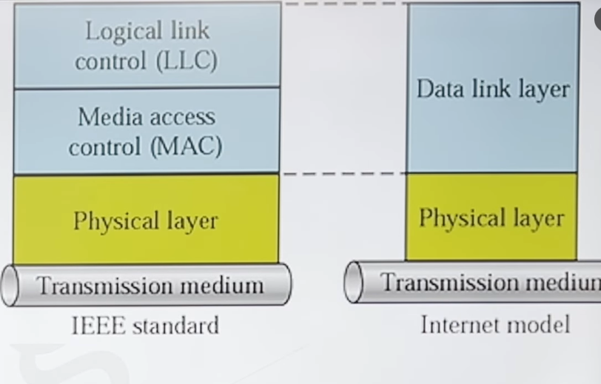

Connectionless and Connection-Oriented
- Connectionless Protocol: Frames are sent from one node to the next without any relationship between the frames; each frame is independent. Connectionless means that there is no connection between frames, it does not imply that there is no physical link between nodes.
- Connection-Oriented Protocol: A logical connection should first be established between the two nodes (setup phase). After all frames that are somehow related to each other are transmitted (transfer phase), the logical
connection is terminated (teardown phase). The frames are numbered and sent in order. If they are not received in order, the receiver must wait until all frames in the set arrive, then deliver them in order to the network layer.

Switching is the technique by which nodes control or switch data to transmit it between specific points on a network.

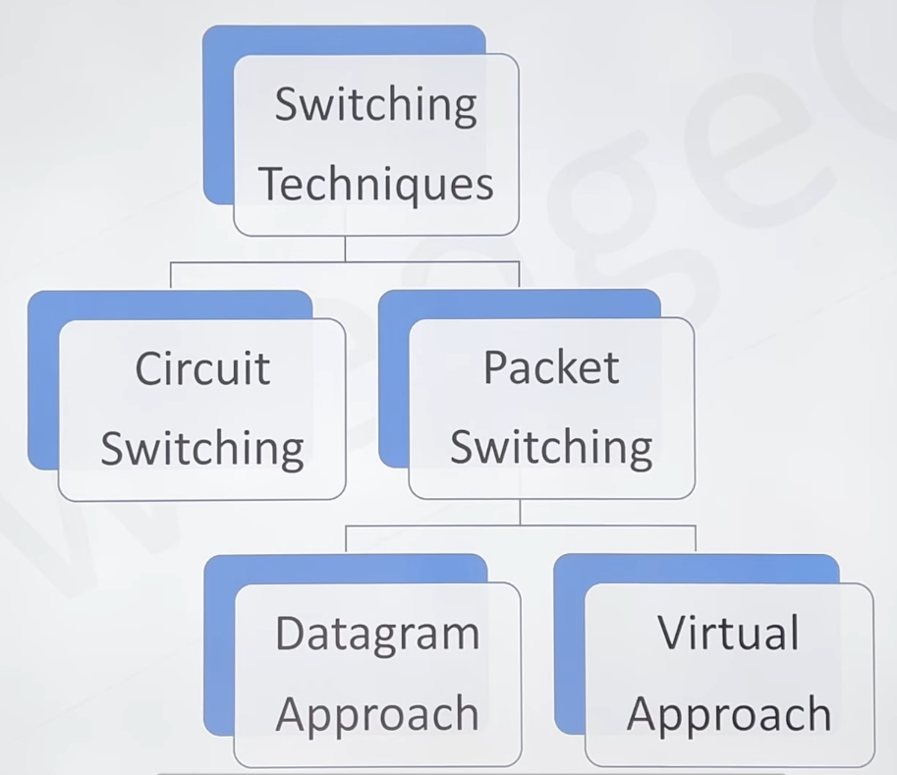

Circuit Switching
- Definition: Circuit switching involves dividing network resources (like bandwidth) into segments and establishing a dedicated path between the sender and receiver. This dedicated path ensures a constant bit delay during the connection and guarantees a specific data rate.

- Operation: Once a circuit is established, data can flow without delays. Circuit switching is commonly used in traditional telephone networks.

Time Division Multiplexing (TDM):
- Divides communication into time slots or frames.
- Transmits independent signals over a shared path using synchronised switches.(E.G: The sending and receiving equipment must agree on the timing. Otherwise, the receiver might mistake Signal A's data for Signal B's data.)
- Used in digital circuit-switched systems, especially for long-distance links with heavy data loads.

Frequency Division Multiplexing (FDM):
- Divides bandwidth into non-overlapping frequency sub-bands.
- Each sub-band carries a different signal.
- Practical applications include radio spectrum and optical fiber communication.
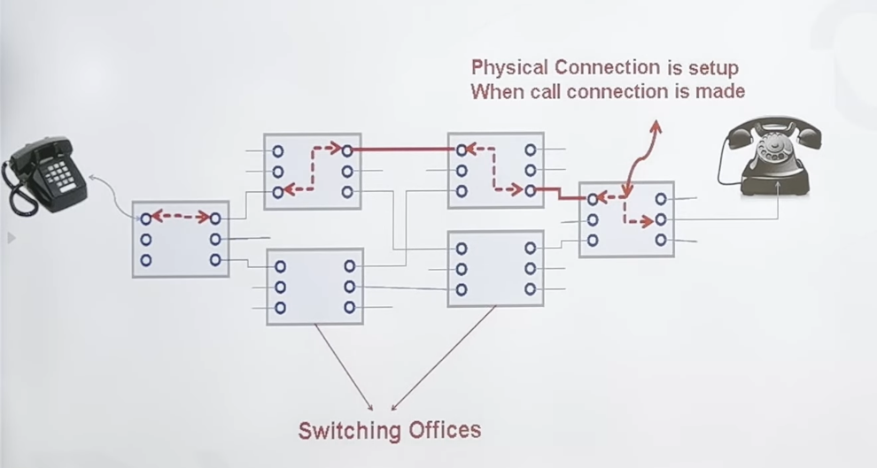

Packet Switching
- Definition: In a packet-switched network, messages are divided into small packets of variable or fixed sizes, determined by the network protocols.
- Resource Allocation: There's no reserved bandwidth or dedicated scheduling for each packet.
- Resources are allocated dynamically based on demand and processed on a first-come, first-served basis.
- Processing & Delays: If a switch is busy with other packets, incoming packets must wait, which may introduce delays. This lack of reservation means potential packet loss or drop if there's insufficient processing capacity.

Datagram Network:
- Treats each packet as independent, regardless of its source or destination.
- Requires upper-layer protocols to handle tasks like reordering packets and requesting lost packets before passing data to applications.
Virtual Network: (A virtual network is a logically created network that uses existing physical network resources instead of needing an entirely separate physical network.)

- Acts as a combination of circuit-switched and datagram networks, providing a middle ground.
- Commonly used in modern telephone networks for efficient data transmission.
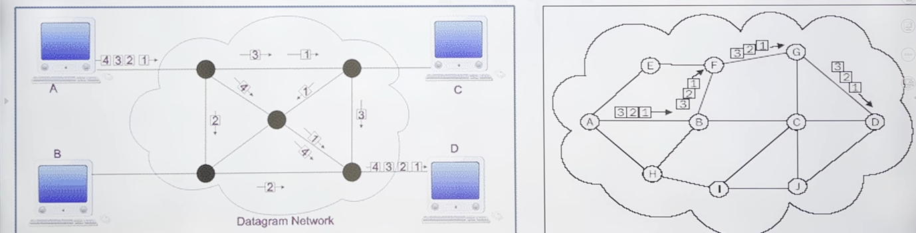

Media Access Control
• When nodes or stations are connected and use a common link, called a multipoint or broadcast link, we need a multiple-access protocol to coordinate access to the link. Many protocols have been devised to handle access to a shared link. All these protocols belong to a sublayer in the data-link layer called media access control (MAC).

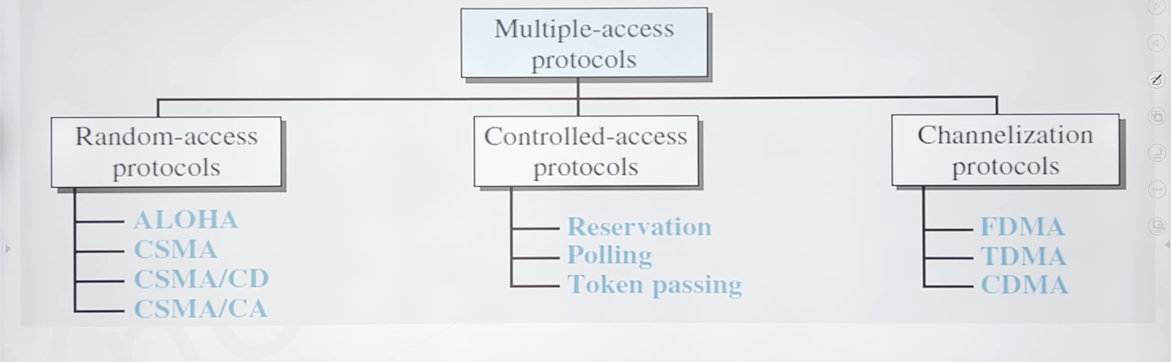

Propagation Delay: Propagation delay is the time it takes for a bit to travel from point A to point B in the transmission medium.

Propagation Speed = Speed at which we are sending the data from two points.

Tp = (Distance) / (Propagation speed)

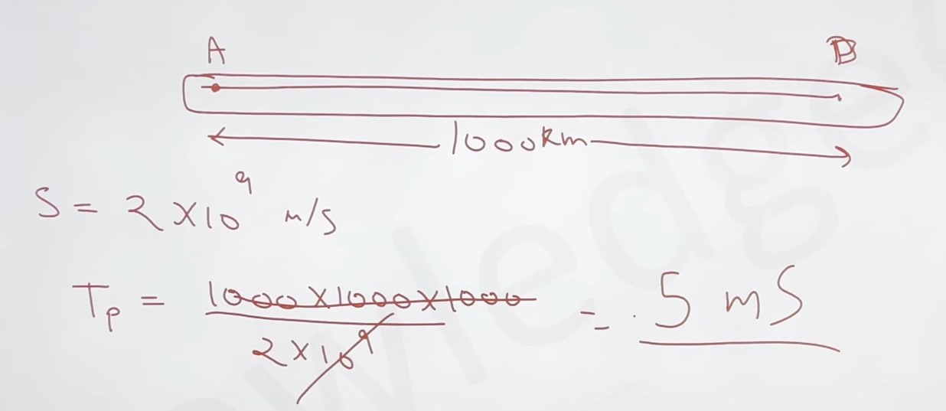

Transmission Delay (TT): A sender needs to put the bits in a packet on the line one by one. If the first bit of the packet is put on the line at time t and the last bit is put on the line at time t, the transmission delay of the packet is (t - t).
T = (Packet length (L)) / (Transmission rate or Bandwidth (B)) = L/ B.
[The simple way to understand this is by thinking about how much time it will take for a device to load (In a way) into the line (the medium) that we are sending the data].

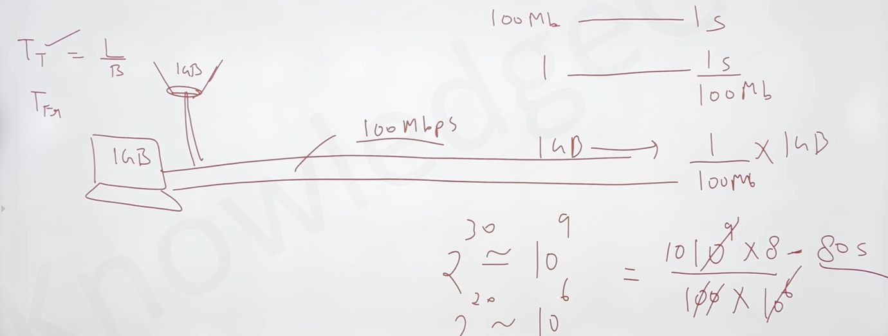

RANDOM ACCESS
- In random access methods, no station is superior to another station, and none is assigned control over another.
- No station permits, or does not permit, another station to send. (Which means that if a station wants to send data to another station, it can access the line at that instance only; it can’t do it whenever it wants to, and when it gets access, it should send the data then only; there should be no delay, and if any collision happens, it has to try again.)
- Two features give this method its name.
- First, there is no scheduled time for a station to transmit. Transmission is random among the stations. That is why these methods are called random access.
- Second, no rules specify which station should send next. Stations compete with one another to access the medium. That is why these methods are also called contention methods.

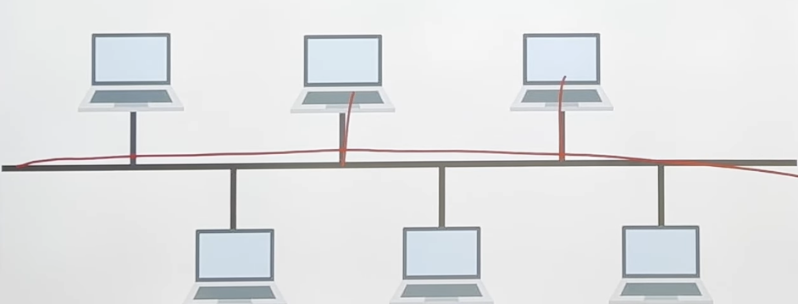

- However, if more than one station tries to send, there is an access conflict-collision-and the frames will be either destroyed or modified.
- All the protocols in the random-access approach will answer the following questions
- When can the station access the medium?
- ﻿﻿﻿What can the station do if the medium is busy?
- ﻿﻿﻿How can the station determine the success or failure of the transmission?
- What can the station do if there is an access conflict?

Aloha

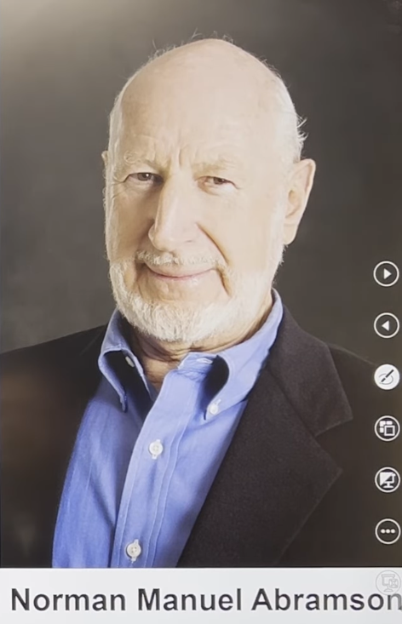

- Earliest random-access method was developed at the University of Hawaii around 1970.
- It was designed for a radio (wireless) LAN, but it can be used on any shared medium.
- The original ALOHA protocol is called pure ALOHA. This is a simple but elegant protocol.
- The idea is that each station sends a frame whenever it has a frame to send. However, there is the possibility of collision between frames from different stations.
- Vulnerable time in which there is a possibility of collision. We assume that the stations send fixed-length frames with each frame taking TS to send.
- Station A sends a frame at time t. Now imagine station B has already sent a frame between t - Tfrand t. This leads to a collision between the frames from station A and station B. The end of B's frame collides with the beginning of A's frame.
- On the other hand, suppose that station C sends a frame between t and t + Tfr Here, there is a collision between frames from station A and station C. The beginning of C's frame collides with the end of A's frame. we see that the vulnerable time, during which a collision may occur in pure ALOHA, is 2 times the frame transmission time.
- Pure ALOHA vulnerable time= 2 x Tfr.
[The way to visualize this is like this imagine u are at a train station and there are no.of platforms and all those rail track on those platform will lead to one single rail track after few miles and lest say at time t, a train left the platform and for that train to reach the next station it first has to go through the single rail track which other rail track uses and then it has to get to that station as well so it will take t+d at this time we don’t want any other rail to have the access to the rail line only the one that we choose should have the accuse at 18:00 a train takes of and it takes 10mins to cross that rail trail and reach next station so for that at after 17:50 we don’t want any other trains to have access cause if they do we assuming that they will take 10mins to get to next station but our train uses track at 18:00 so there are chances of having a collision. So we want 10(to make sure no collision)+10(to reach the next station) time to make sure no collisions occur and that time will be 2xtransition delay.] 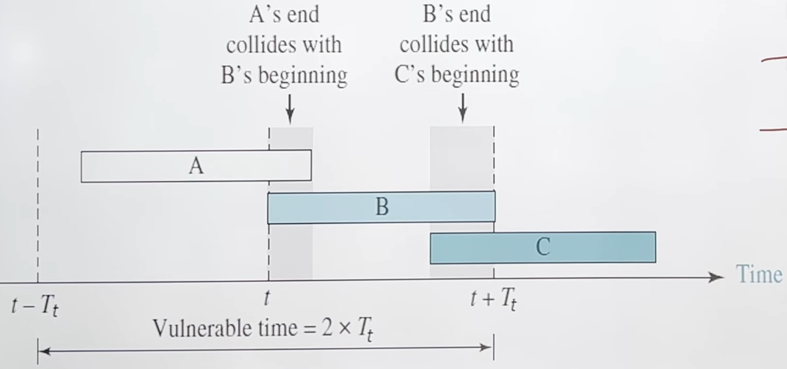
- The pure ALOHA protocol relies on acknowledgements from the receiver. When a station sends a frame, it expects the receiver to send an acknowledgement.
- If the acknowledgement does not arrive within the timeout period, the station assumes that the frame (or the acknowledgement) has been destroyed and resends the frame.
[It means a device sends data and waits for an acknowledgement from the receiver. It waits until it gets it; once it does, we can say there was no collision. If it doesn't, we can resend the data again until we get the acknowledgement we want]
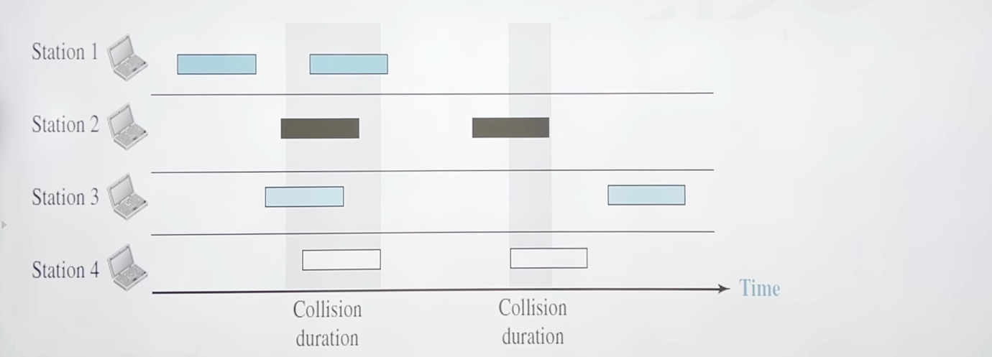

- First we send the frames with no check cause we don’t check the medium if there is another device who is also using it we don’t check and we just proceed with it.
- We send frame and wait till we get an acknowledgement from the receiver for 2xTp and we get the acknowledgement we will then conclude that it was a success if not what we do is that we increase the K by 1 and then we check it with kmax(we do this so that there should be only a no.of time a device should send a frames if it does more than that we can say that there is lot of collision happening right now and we can do it later) and we and its less than kmax so the we go to next stage where we have to choose a random number and then we have to multiply that with Tp or Tfr we do this cause to make sure that if there is any other device who is also sending frames and it will also go through same procedure and it will also pick a random number the chances of both devices selecting same number is so low, and by doing this there will be less possibility of collision happening that’s the procedure of pure ALOHA and understand we are doing this only in a medium where the chances of collision happening less not impossible but less and when the collision does happen how to handle that’s what pure aloha is about )
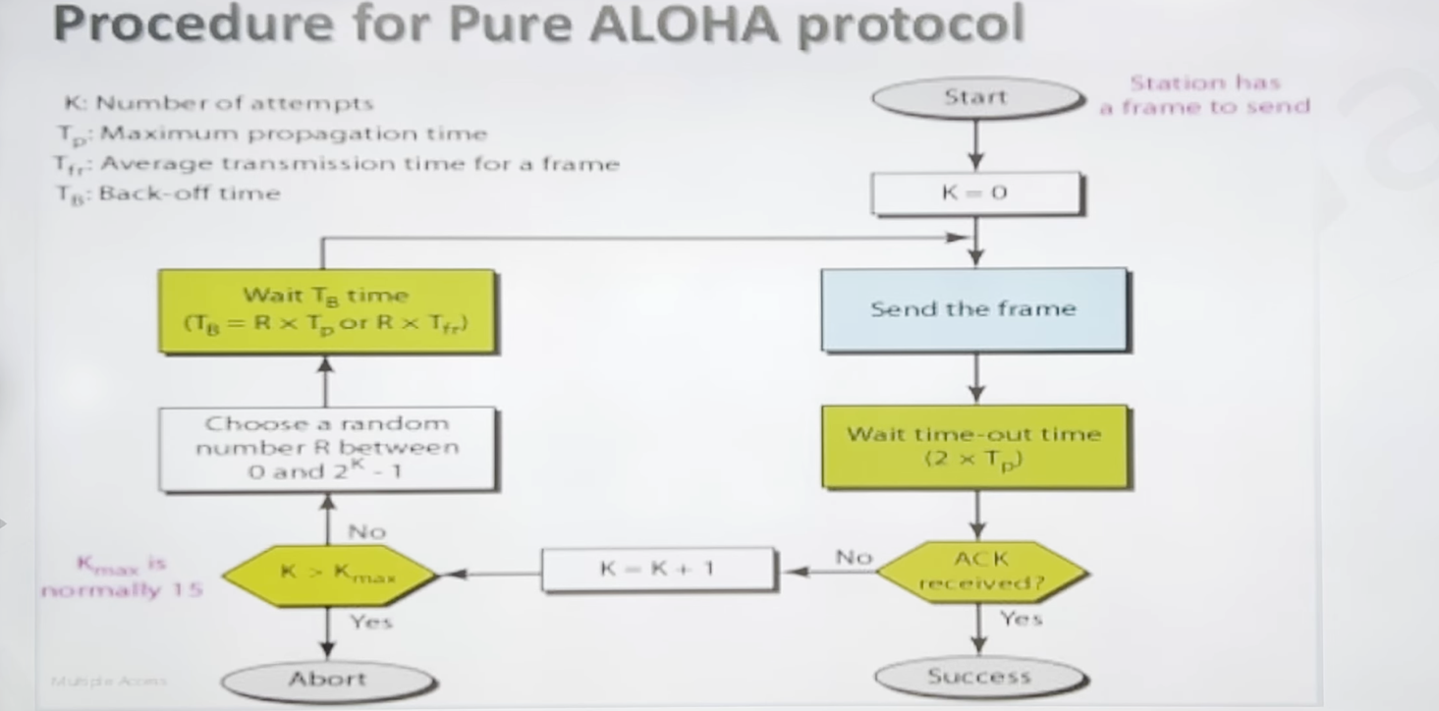
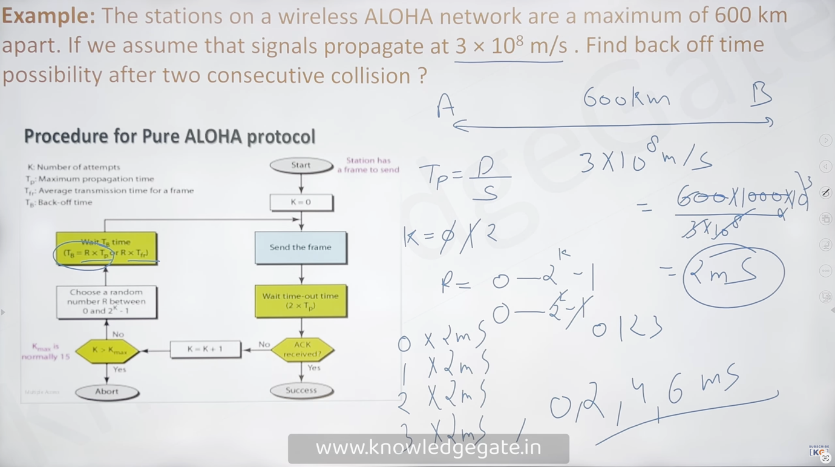

Example: A pure ALOHA network transmits 200-bit frames on a shared channel of 200 kbps. What is the requirement to make this frame collision-free?

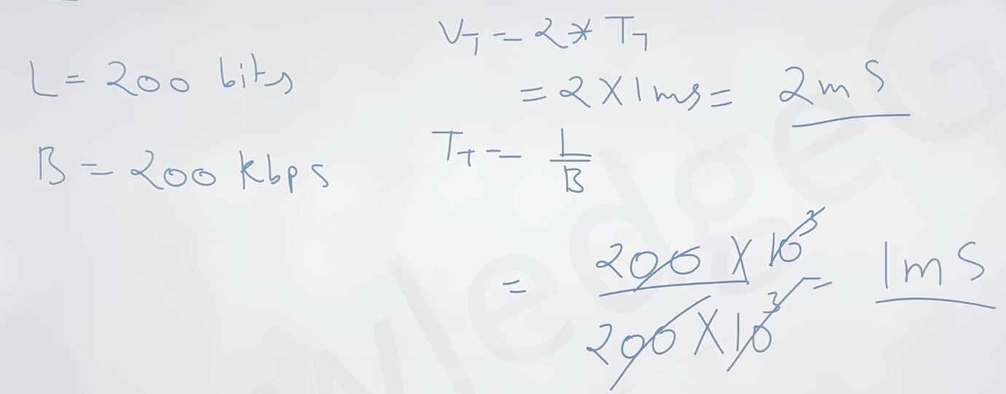

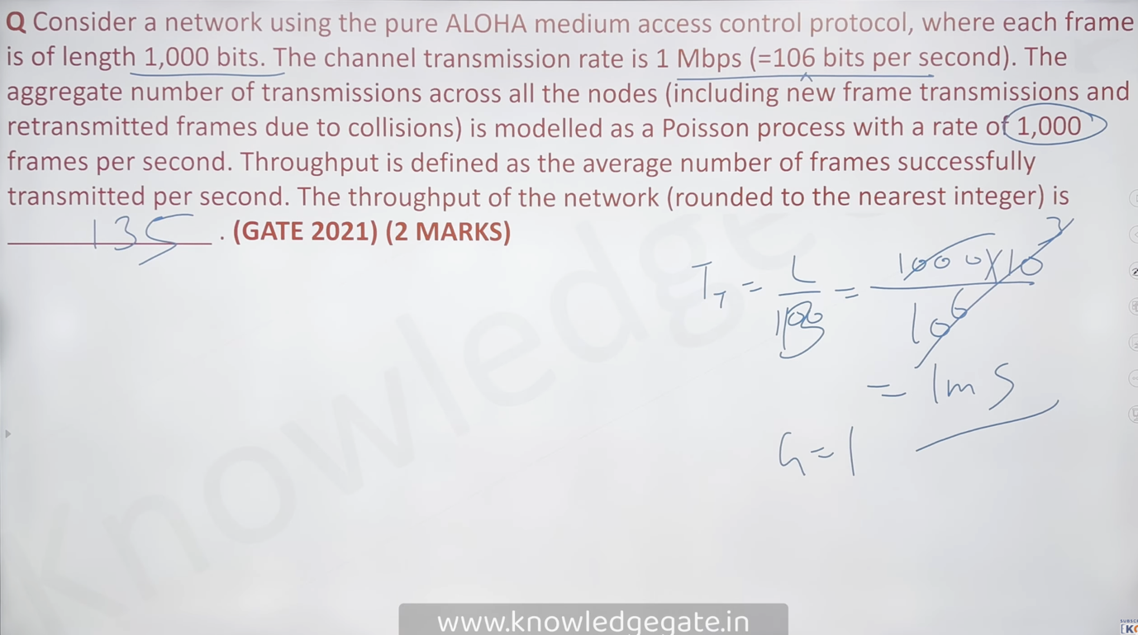

Slotted ALOHA

- Pure ALOHA has a vulnerable time of 2 x Tf. This is because there is no rule that defines when the station can send. A station may send soon after another station has started or soon before another station has finished.
- Slotted ALOHA was invented to improve the efficiency of pure ALOHA. In slotted ALOHA, we divide the time into slots and force the station to send only at the beginning of the time slot. [If you have noticed that in pure ALOHA, collisions used to happen in a way where we are getting collided by tail to head and head-to-tail, and the vulnerable time was going 2xTp, and to make this time less, what we are trying to do is that we are making sure that the slots are allotted; even if the collision happens, they will happen head-on, and the vulnerable time will become Tp.]
- Because a station is allowed to send only at the beginning of the synchronised time slot, if a station misses this moment, it must wait until the beginning of the next time slot. This means that the station which started at the beginning of this slot has already finished sending its frame.
- ﻿﻿Of course, there is still the possibility of collision if two stations try to send at the beginning of the same time slot. However, the vulnerable time is now reduced to one-half, equal to Tfr.

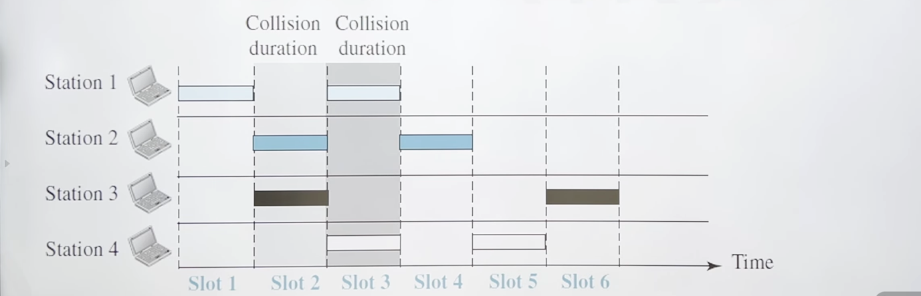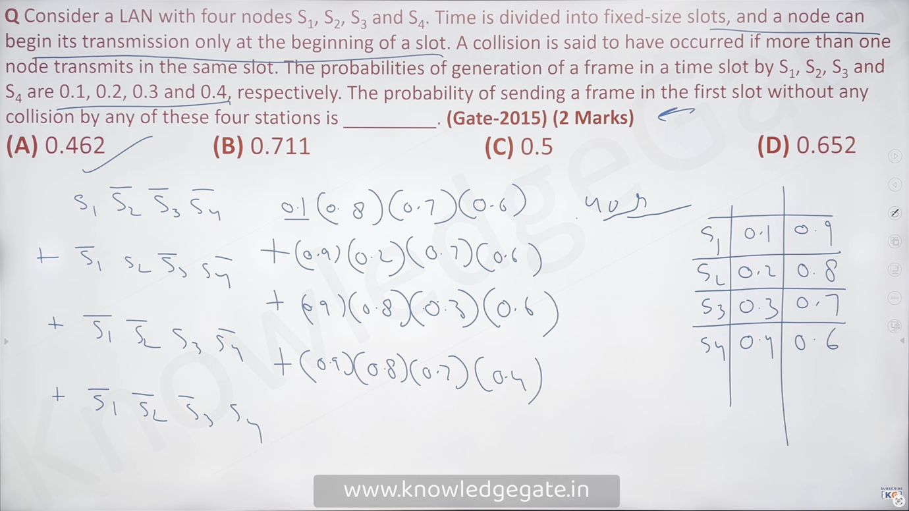
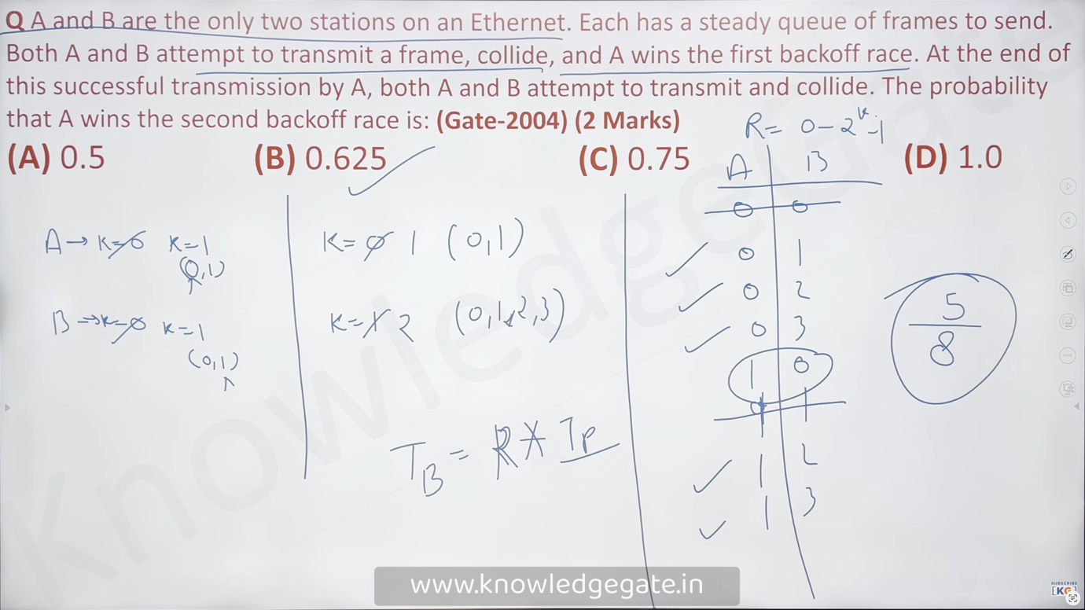

Carrier Sense Multiple Access (CSMA)
- To minimize the chance of collision and, therefore, increase performance, the SMA method was developed. The chance of collision can be reduced if a station senses the medium before trying to use it.
- Carrier sense multiple access (CSMA) requires that each station first listen to the medium (or check the state of the medium) before sending, so "sense before transmit" or listen before talk." CSMA can reduce the possibility of collision, but it cannot eliminate it.
- The possibility of collision still exists because of propagation delay; when a station sends a frame, it still takes time (although very short) for the first bit to reach every station and for every station to sense it.
[In ALOHA what we used to do is that whenever a device has data to send, it will send immediately without considering if there is any other device that is accessing it at that time; that’s what we were doing in ALOHA, but in CSMA, what we are doing is that we are allowing the device to send the frames, but we are also asking it to be considerate when some other system is also in use]

- In other words, a station may sense the medium and find it idle, only because the first bit sent by another station has not yet been received.
- ﻿﻿At time t, station B senses the medium and finds it idle, so it sends a frame. At time t2 (t2> t1), station C senses the medium and finds it idle because, currently, the first bits from station B have not reached station C. Station C also sends a frame. The two signals collide, and both frames are destroyed.
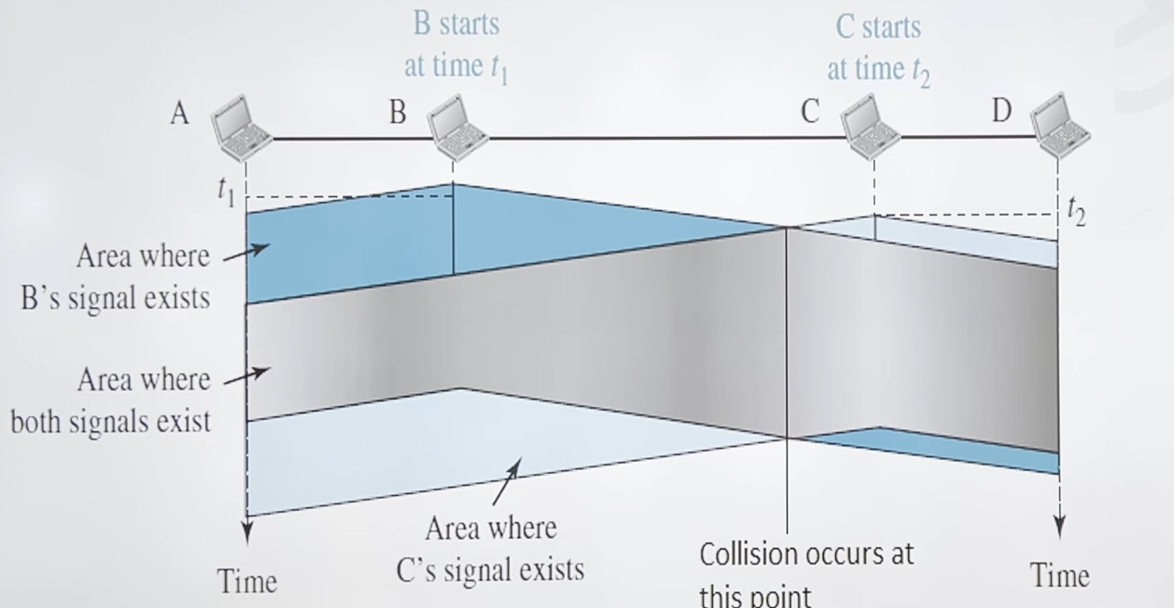

Vulnerable Time
- The vulnerable time for CSMA is the propagation time Tp.
- When a station sends a frame, and any other station tries to send a frame during this time, a collision will result.
- But if the first bit of the frame reaches the end of the medium, every station will already have heard the bit and will refrain from sending.
- Station A has sent a frame at a time which reaches the rightmost station, D, at time t+ Tp.

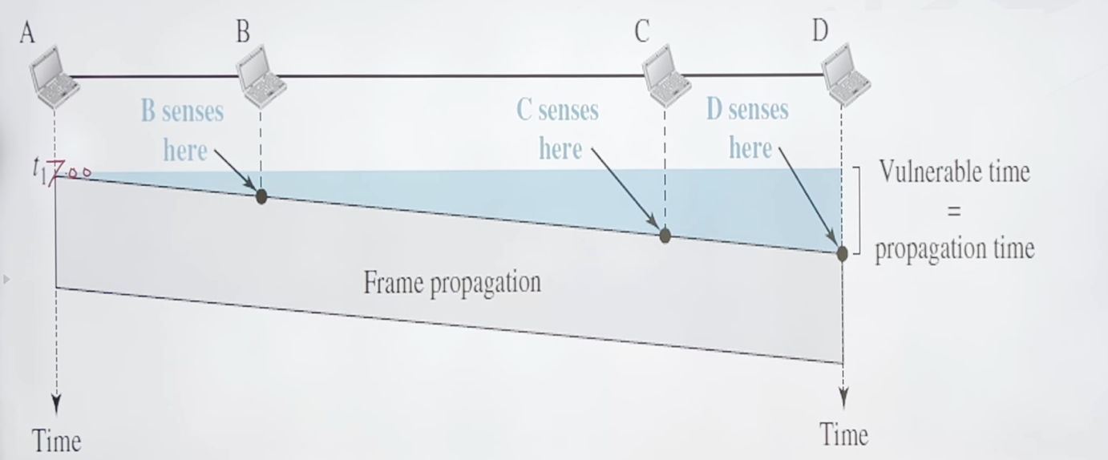

Persistence Methods
What should a station do if the channel is busy? What should a station do if the channel is idle?
Three methods have been devised to answer these questions:
- 1-persistent method
- Non-persistent method
- P-persistent method

- 1-Persistent

﻿﻿The 1-persistent method is simple. In this method, after the station finds the line idle, it sends its frame immediately (with probability 1). This method has the highest chance of collision because two or more stations may find the line idle and send their frames immediately.

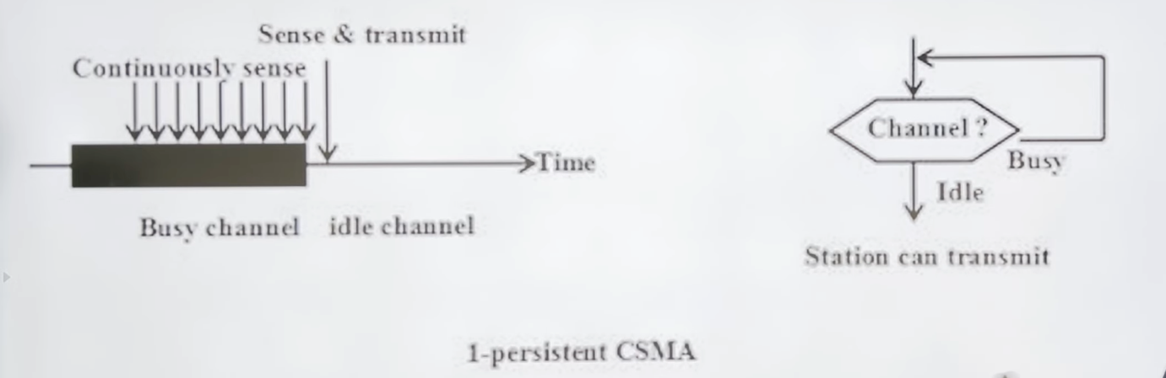

- Nonpersistent

- In the nonpersistent method, a station that has a frame to send senses the line. If the line is idle, it sends immediately. If the line is not idle, it waits a random amount of time and then senses the line again.
- The nonpersistent approach reduces the chance of collision because it is unlikely that two or more stations will wait the same amount of time and retry to send simultaneously. However, this method reduces the efficiency of the network because the medium remains idle when there may be stations with frames to send.
[Perks of this method is you can set priority; if there is a device whose priority is highest, we can minimise the wait time for that device and if there is a device whose priority is lowest, we can set the wait time longer ]
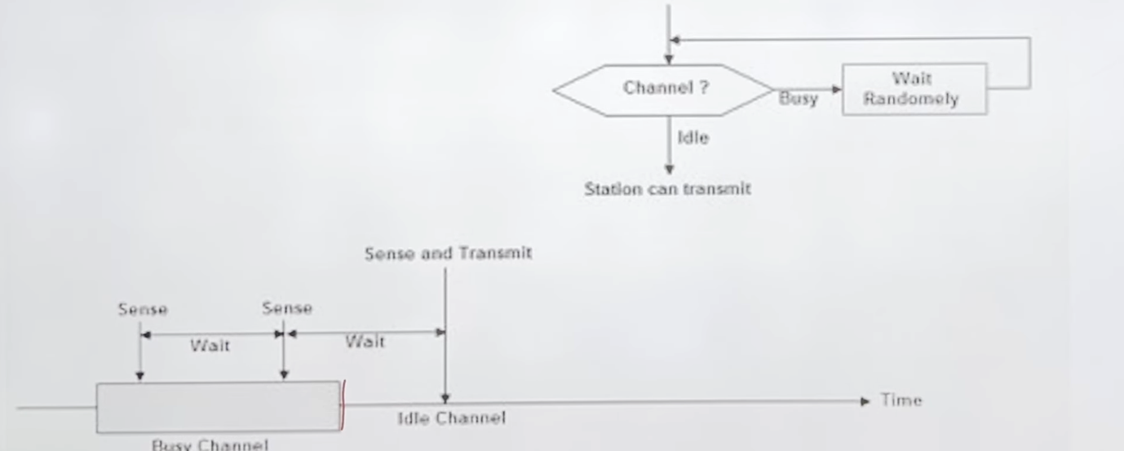

- P-Persistent

- The p-persistent approach combines the advantages of the other two strategies. It reduces the chance of collision and improves efficiency. In this method, after the station finds the line idle it follows these steps:
- With probability p, the station sends its frame.
- With probability q = 1-p, the station waits for the beginning of the next time slot and checks the line again.
- a. If the line is idle, it goes to step 1.
- b. If the line is busy, it acts as though a collision has occurred and uses the backoff procedure.
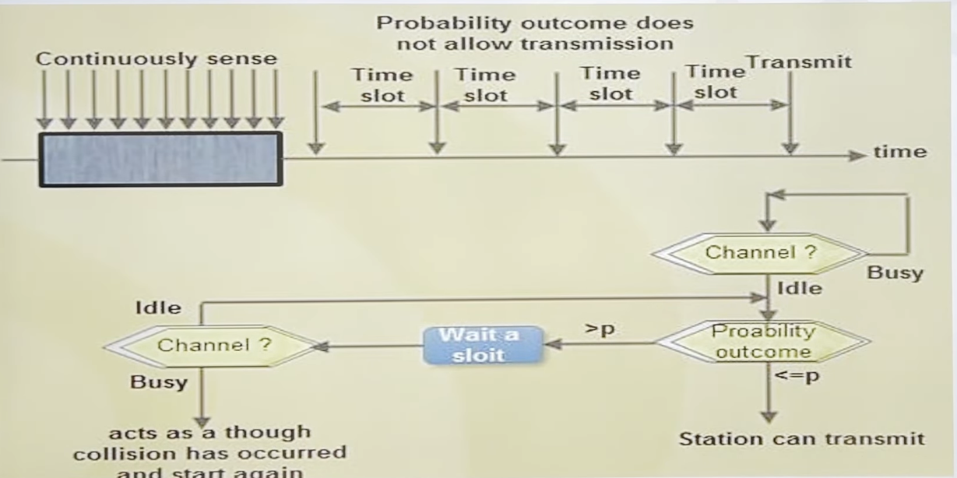

Carrier Sense Multiple Access with Collision Detection (CSMA/ CD)

- In this method, a station monitors the medium after it sends a frame to see if the transmission was successful. If so, the station is finished. If, however, there is a collision, the frame is sent again.
- Minimum Frame Size - For CSMA / CD to work, we need a restriction on the minimum frame size. Before sending the last bit of the frame, the sending station must detect a collision, if any, and abort the transmission.
- This is so because the station, once the entire frame is sent, does not monitor the line for collision detection. Therefore, the frame transmission time Tmust be at least two times the maximum propagation time Tp.
- To understand the reason, let us think about the worst-case scenario. If the two stations involved in a collision are the maximum distance apart, the signal from the first takes time T to reach the second, and the effect of the collision takes another time Tp to reach the first. So the requirement is that the first station must still be transmitting after 2Tp.

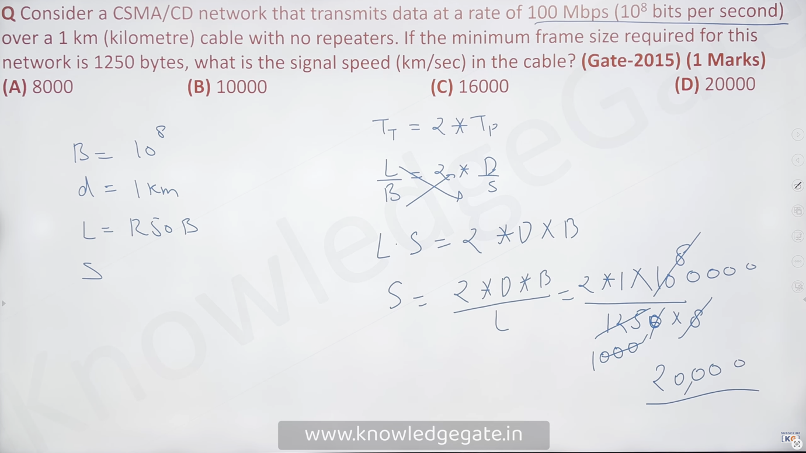

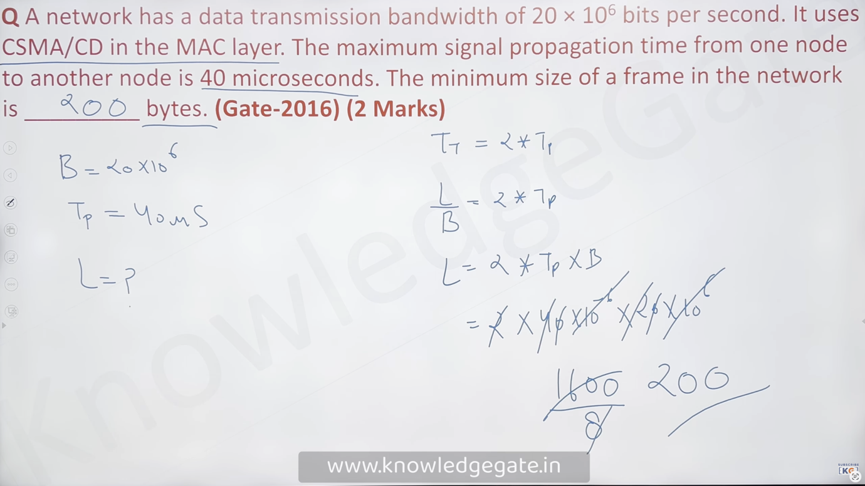

[The one exception CSMA/CD has is that, in the wireless medium, the chances of sensing a collision are much lower than in the wired medium. In the wired medium, let’s say a packet has an energy of 5 V and no collision happens, so the energy remains the same. If a collision happened, the energy would go up to let’s say, 10 V. We can easily detect this in the wired medium, but in the wireless, even if a collision happens, sensing the energy gets so hard that we will hardly ever detect it; that’s(f proportional to 1 by r sq) why we don’t use csma/cd in the wireless medium]

Energy Level

- We can say that the level of energy in a channel can have three values: zero, normal, and abnormal. At the zero level, the channel is idle. At the normal level, a station has successfully captured the channel and is sending its frame.
- At the abnormal level, there is a collision and the level of the energy is twice the normal level. A station that has a frame to send or is sending a frame needs to monitor the energy level to determine if the channel is idle, busy, or in collision mode.
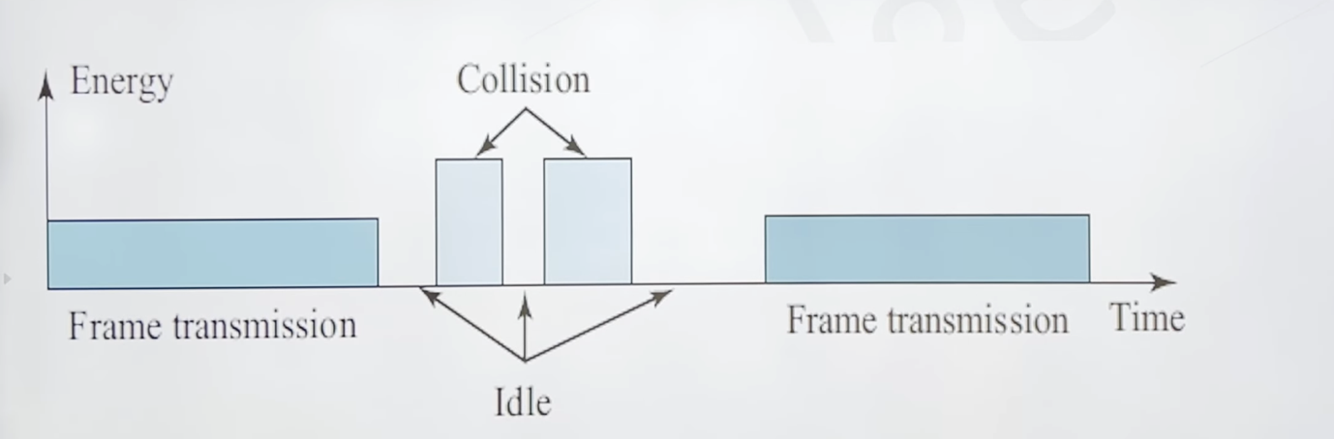

Carrier Sense Multiple Access with Collision Avoidance (CSMA/CA)

- In a wireless network, much of the sent energy is lost in transmission. The received signal has very little energy.
- Therefore, a collision may add only 5 to 10 per cent additional energy. This is not useful for effective collision detection.
- We need to avoid collisions on wireless networks because they cannot be detected. Carrier sense multiple access with collision avoidance (CSMA/CA) was invented for this network. Collisions are avoided through the use of
- CSMA / CA
• three strategies: the interframe space, the contention window, and acknowledgement

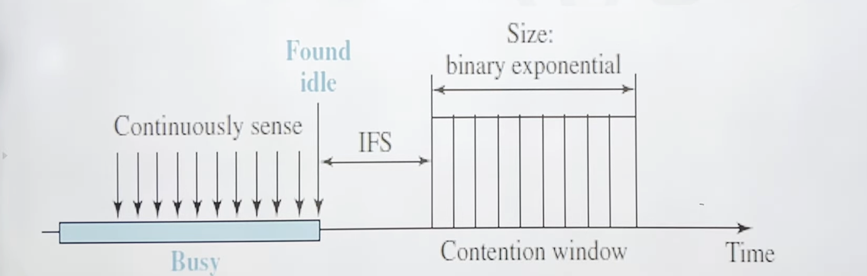

Interframe Space (IFS)
- First, collisions are avoided by deferring transmission even if the channel is found idle. When an idle channel is found, the station does not send immediately.
- It waits for a period of time called the interframe space or IFS.
﻿﻿The IFS time allows the front of the transmitted signal by the distant station to reach this station. If after the IFS time the channel is still idle, the station can send, but it still needs to wait a time equal to the contention time. The IFS variable can also be used to prioritize stations or frame types.

Contention Window

- The contention window is an amount of time divided into slots. A station that is ready to send chooses a random number of slots as its wait time.
- The number of slots in the window changes according to the binary exponential back-off strategy.
- This means that it is set to one slot the first time and then doubles each time.
- One interesting point about the contention window is that the station needs to sense the channel after each time slot.
- However, if the station finds the channel busy, it does not restart the process; it just stops the timer and restarts it when the channel is sensed as idle. This gives priority to the station with the longest waiting time.

Acknowledgment

- ﻿﻿With all these precautions, there still may be a collision resulting in destroyed data. In addition, the data may be corrupted during the transmission. The positive acknowledgement and the time-out timer can help guarantee that the receiver has received the frame.

Note: You have to think of this like this: random-access control has less traffic; controlled access has more traffic compared to random-access and the channelisation protocol has more traffic compared to random-access and controlled access

CONTROLLED ACCESS

• In controlled access, the stations consult one another to find which station has the right to send. A station cannot send unless it has been authorised by other stations. We discuss three popular controlled-access methods.

Reservation
- Purpose: Stations make a reservation before sending data, which helps in organizing transmissions and avoiding collisions.
- Timeline Structure: Reservation Interval: A fixed time length dedicated to reserving slots. Data Transmission Period: A variable period for transmitting data frames.
- Slot Allocation: If there are M stations, the reservation interval is divided into M slots, with each station having one slot. If a station (e.g., Station 1) has a frame to send, it indicates this by transmitting a 1-bit signal during its respective slot. No other station is allowed to transmit during another station's slot.
- Announcement & Data Transfer: Any station that wants to send data announces it by marking its respective slor.
- Once all slots have been checked, each station knows which other stations intend to transmit. Stations that have reserved slots transmit their frames in the agreed order, avoiding collisions. Process Continuation: After the data transmission period, a new reservation interval begins. This method ensures an orderly data transfer, preventing any collisions by having a clear agreement on which station transmits next.

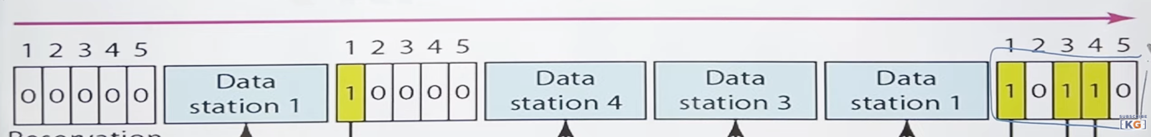

Polling
• Polling works with topologies in which one device is designated as a primary station and the other devices are secondary stations. All data exchanges must be made through the primary device even when the ultimate destination is a secondary device. The primary device controls the link; the secondary devices follow its instructions. It is up to the primary device to determine which device is allowed to use the channel at a given time.
• Select
The select function is used whenever the primary device has something to send. Remember that the primary controls the link. If the primary is neither sending nor receiving data, it knows the link is available. If it has something to send, the primary device sends it. What it does not know, however, is whether the target device is prepared to receive. So the primary must alert the secondary to the upcoming transmission and wait for an acknowledgment of the secondary's ready status. Before sending data, the primary creates and transmits a select (SEL) frame, one field of which includes the address of the intended secondary.

- Poll
The poll function is used by the primary device to solicit transmissions from the secondary devices. When the primary is ready to receive data, it must ask (poll) each device in turn if it has anything to send. When the first secondary is approached, it responds either with a NAK frame if it has nothing to send or with data (in the form of a data frame) if it does. If the response is negative (a NAK frame), then the primary polls the next secondary in the same manner until it finds one with data to send. When the response is positive (a data frame), the primary reads the frame and returns an acknowledgment (ACK frame), verifying its receipt.
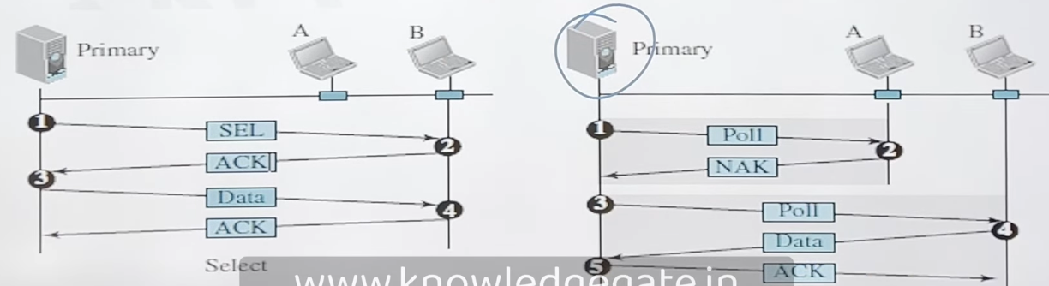

Token Passing
- Token passing is a method used to control access to the network in a logical ring topology. In this approach, a special packet called a token circulates among the stations, allowing them to transmit data only when they hold the token.
- Logical Ring Topology: Stations are organised in a logical ring, where each station has a predecessor and a successor. The predecessor is the station logically before, and the successor is the one after in the ring.
- Token Circulation: The token is a special packet that circulates through the ring, granting permission to a station to access the communication channel. Only the station holding the token can transmit data. When a station has data to send, it waits to receive the token from its predecessor. After sending its data, the station releases the token to its successor in the ring.
- Token Management: Time Control: The time a station can hold the token must be limited to prevent monopolisation. Token Monitoring: 71 ensure network integrity, the token must be tracked, especially to detect if it is lost or if a station holding it fails. Priority Assignment: Token management allows assigning priorities to stations and the types of data transmitted, ensuring critical information gets transmitted first.
- Handling Failures: When a station holding the token fails, it is essential to regenerate or reassign the token to maintain network functionality. Data Transmission and Token Passing: When a station receives the token but has no data to send, it immediately passes the token to the next station. A station must wait for the next round to transmit if it has already passed the token in the current round.



